TRAFFIC SQUAD DATABASE MANAGEMENT SYSTEM

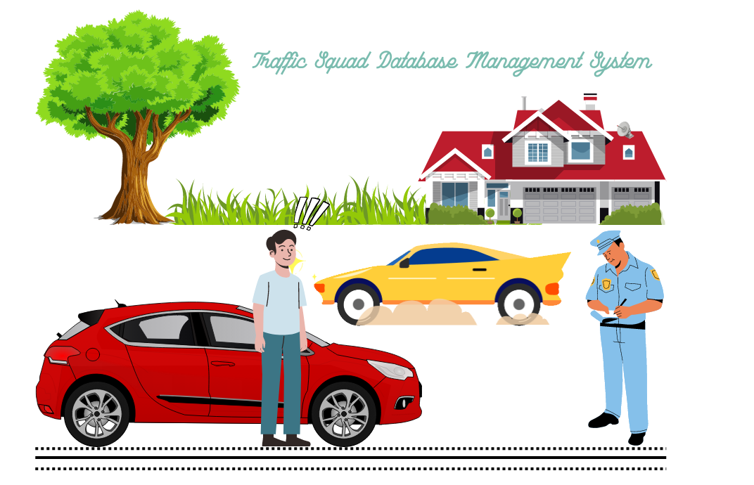

**PROJECT BY:**

**Mobeen Saeed** BCS213072

**Ruquiya Nasir** BCS213065

**Laiba Shahzadi**  BCS213053

**Submitted to:**

Sir Salman Ahmed

All about Project

“*Traffic Squad Management System* “would help the traffic police head office as well as the police officer through time and efficiency. The increasing importance of corruption has become a major factor. Online challan system helps the driver to get their license easily on the spot.

The system maintains a record of police officers working in the police station that has a unique *name, location, and code*.

After a traffic police staff is registered all the traffic police officer that belongs to that specific station has all his/her records stored in them, which includes *name, id, Rank, contact number, address, qualification, e-mail, and CNIC*.

An officer can file a challan that has a unique number, place of violation, and offense date stored for all those people breaking traffic rules. Only one officer can challan zero or many offenders. Moreover, an officer can search that challan details through challan number and, offender name and can view its details and status that whether it is paid or not, and the number of challans filed by him/her in particular periods.

If a citizen violates any traffic rules then an officer generates a challan for him/her that contains information about that offender, his/her vehicle, and the violation done by him/her.

The Violation list consists of all the details regarding the offense like *violation Id, Section act, violation name, and its penalty*. An offender can do and officer can charge many violations.

Offender details recorded are *Id, name, license number, license type, address, gender, contact number, CNIC, and E-mail*. And its vehicle details include a unique *number plate number, vehicle name and its type*. An offender can has one or many vehicle.

The offender would receive the challan receipt with fine details and have to log in to pay the challan fine which is imposed by traffic police. Furthermore, they can search challan by its number.

**THE END!!**